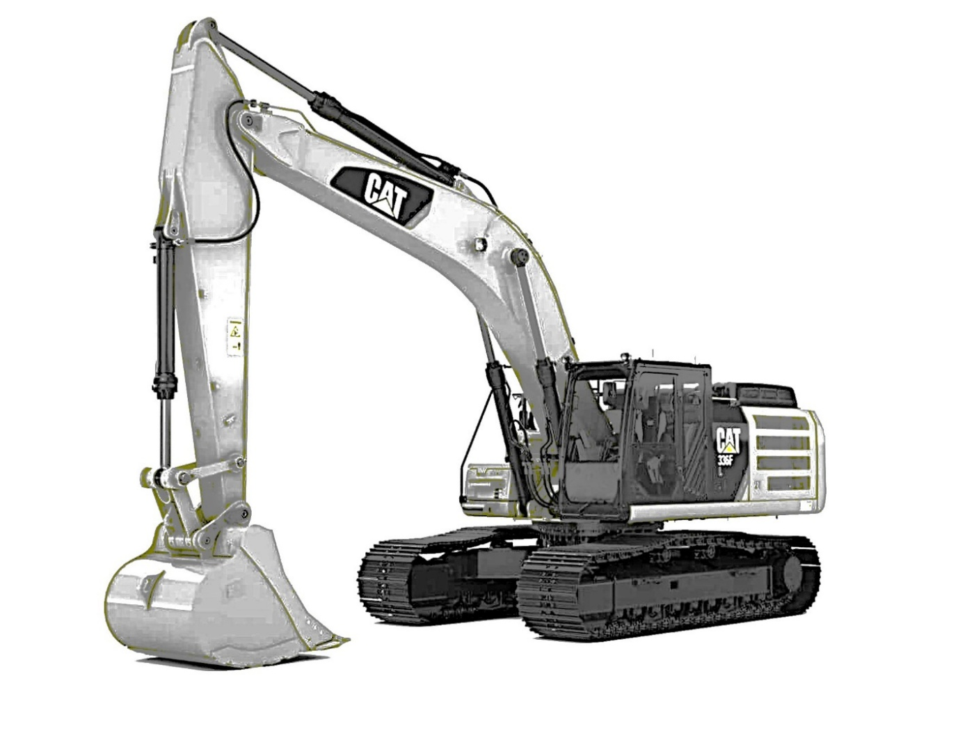

Caterpillar 395 Excavator

User Manual

Table of Contents

Table of contents 4

Warnings 4

Engine warnings 4

Hydraulic warnings 4

Proper Shut down 4

Things to watch for 5

System Requirements / Specifications / Parts List 5

Excavator Specifications 5

Included Parts 5

Assembly / Installation / Preparation / Setup 5

Starting the Excavator 5

Checking if a Part is Broken 8

Why Check Parts? 9

Quick start guide 10

Starting / Stopping the machine 10

Lifting 10

Digging 10

Refueling 10

Out of DEF 10

Normal Use 11

Instructions 11

Shutting down / Stopping 11

Fixing parts 12

Refueling 13

Lifting 14

Digging 16

Proper shutdown sequence 17

Maintenance 17

What are Error Codes for? 17

Troubleshooting the Excavator 18

The excavator does not start 18

Key 18

Engine 18

Engine Oil 18

The turbo 18

Fuel 18

Fuel pump 19

Fuel lines 19

Fuel Filter 19

Battery 19

Other Parts that are Also Critical 19

Alternator Belt 19

Alternator 20

Fuel Pump Belt 20

DEF Tank 20

Engine Air Filter 20

Radiator Fan Belt 20

Radiator Filter 20

Radiator Fins 20

Radiator Coolant 21

Radiator Pump 21

Engine Oil Filter 21

The excavator will not dig / lift 21

Safety Bar 21

Hydraulic Oil 21

Hydraulic Oil Pump 21

Glossary of Terms 21

Common Problems 23

Support 23

Preventative Maintenance Checklist 23

Situational Error Codes Table 24

WHEN STARTING 24

WHEN DIGGING / LIFTING 24

WHEN STOPPING 25

WHEN INSPECTING 25

Complete Error Codes List 25

# Table of contents

# Warnings

## Engine warnings

Shutting down the engine while the machine is running the turbo, because it is too hot. You must cool down the machine. You shut off the machine incorrectly by choosing option 5 in the menu – turn key. You must instead choose option 2, which allows for a cooling down process.

The engine oil must stay under 1000 degrees. Any more over this, and the engine will be destroyed, and the sudden shut down will also destroy the turbo.

## Hydraulic warnings

The maximum lifting capacity of the 395 Excavator is 205,000 lbs. Lifting items heavier than this will destroy the hydraulic pump and stall the engine, which also causes the turbo to be destroyed due to its abrupt stop at high temperatures.

## Proper Shut down

The turbo gets very hot while working. The machine must be cooled, then shut down. You do this by selecting option 2 from the main menu. Then, you will enter the letter ‘n’ to cool down the machine.

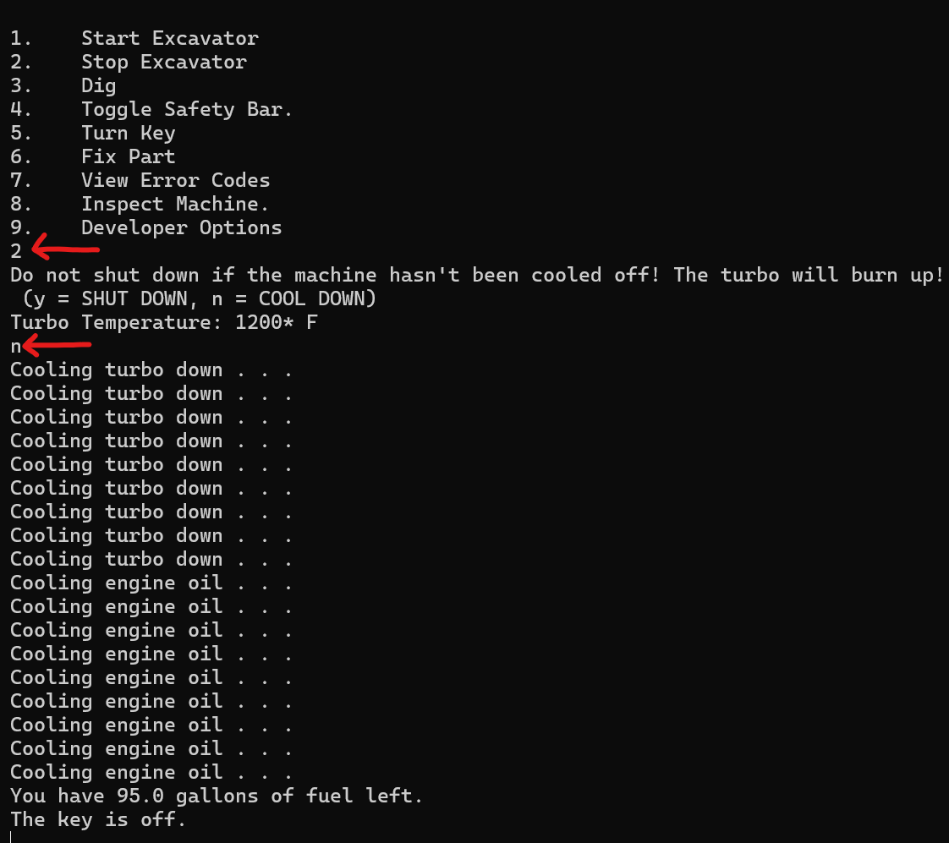

## Things to watch for

Fixing parts before they fail is a great idea. There is a list of parts that fail in the maintenance schedule. See *Preventative Maintenance Schedule* under *Support* in the *Troubleshooting guide*.

# System Requirements / Specifications / Parts List

## Excavator Specifications

Lifting Capacity: 205,000 lbs. / 93.12 Metric Tons

Fuel: 100 gallons

Bucket Capacity: 6.8 cubic yards

## Included Parts

The excavator is fully functional out of the box. There should be no setup required.

# Assembly / Installation / Preparation / Setup

## Starting the Excavator

The goal is to dig with the excavator. To do so, it must be ‘cranked’ or ‘turned on’ and the parts all in working order. Below is a step-by-step guide on how to start the excavator. **You interact with the excavator using text or numbers entered from your keyboard.** You enter a number, then press enter to do something. The following steps will be covered: turning the key on, starting the engine, and lowering the safety bar.

1. To turn the key on, Enter the number 5 using your keyboard, and press enter. This selects option 5, “turn key” from the startup screen. Press enter again. This will refresh the program.

1. If all is well, you will see a GAUGES screen above your options. This shows information about your excavator that is helpful for troubleshooting and safe operation.

1. To start the excavator, “crank the engine” or “turn it on”, enter the number 1 and press enter. If you see 0 error codes, the machine should start. It should say VROOM and start.

1. You will notice nothing happens. Press enter again, and your gauges will change.

1. You cannot dig yet. You must toggle a safety bar, which prevents unintentional moving of the excavator before you want to dig. This is a safety feature. If you do not know what this is, you can consult the glossary. Deactivate the safety bar by entering the number 4 and pressing enter.

1. You may now dig, as long as there are no error codes. Enter the number 3 to dig. You will see your amount of dirt moved increase.

## Checking if a Part is Broken

If you suspect a part is broken or nearing end of life, you may inspect it. You do this through option 8. Enter the number 8 into the option menu, and press enter.

Here, you may choose from a list of parts by entering the number of the part you wish to take a closer look at, and check if it is operating fine. There will be a description of what the part looks like, if it is working fine, etc.

In this instance, the number 13 was entered as an example to show how to check the 13th item on the list of parts. This short description was sent out: “You place your voltmeter leads across the battery terminals. The battery is sufficiently charged.”

You may check any part you wish on the list by entering its associated number.

In this instance, the fuel pump belt was a suspected issue. The number 3 was entered, and the user pressed enter. A message shows up, saying that the part has been broken.

# Why Check Parts?

The machine does not tell you the name of the part that is broken, it can only give symptoms. It is necessary to know what part is broken, if you are going to fix it. The machine tells you what part is broken by using symptoms, which you can look up in the manual. There is a table in the manual which relates an error code, symptom, and broken part.

1. Machine is functional
2. part breaks
3. look up symptom in manual
4. determine which part is broken through symptoms
5. fix part by entering its error code.

# Quick start guide

## Starting / Stopping the machine

You must enter options 5 (turn key) , 1 (start machine) , and 4 (lower safety bar) to dig.

You can dig until your machine breaks or meets its preventative maintenance schedule.

Fix parts that are broken.

Return to digging.

If you need to stop the machine, select option 2, then option ‘n’ to cool down.

## Lifting

To life, select option 9 from the menu. You will be presented with 10 options. Select the item you want to lift. Your income will increase when you lift items.

## Digging

Use option 3 to dig. You can dig until you break something. Digging increases your income.

## Refueling

If your excavator is out of fuel, you will need to refuel it to continue operations. This is the same as fixing a part, and the error code is 0xAAAA

## Out of DEF

If your excavator is out of DEF, you will need to fill the tank to allow for proper lifting capacity, digging capacity, and speed. To fix this, use error code 0xAAAF. You will know you are out of DEF when you see this error:

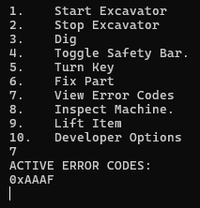

To fix this error, you will need to choose option 6 from the menu, and then enter the 0xAAAF code to purchase DEF and fill the tank.

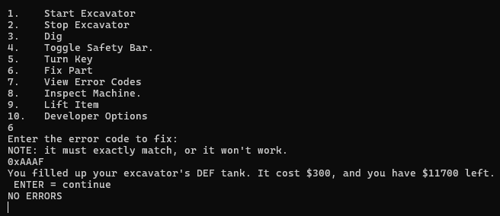

# Normal Use

## Instructions

The excavator is intended to dig or lift. You can dig by turning the key, starting the excavator, lowering the safety bar, and then choosing the dig option or the lift option.

You want to lift and dig because that makes money. You will need money to fix your excavator when it breaks. Some parts are extremely expensive – especially the engine.

If you need to stop the machine, use option 2 from the menu. This will allow you to shut down the machine without breaking it, and allow for maintenance to be performed.

## Shutting down / Stopping

The turbo gets very hot while working. The machine must be cooled, then shut down. You do this by selecting option 2 from the main menu. Then, you will enter the letter ‘n’ to cool down the machine.



## Fixing parts

If a part is broken, there will be an error code thrown. To fix the part, the operator must have the error code related to that issue. The steps will be shown to get the error code.

1. Shut the machine down, if it hasn’t done so already. This is done by selecting option 2, then option “n” to cool down.
2. Choose option 7 to view what codes have been thrown.

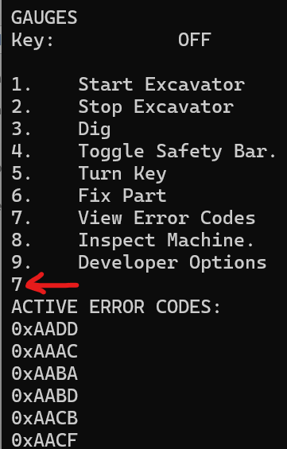

1. Now you know what error codes have been thrown, you can see what is broken on your excavator. Look up the error codes in the *Troubleshooting Guide* under *Complete Error Codes List*
2. Typing in error codes is easy when you have the list in front of you. It is best to have 1 window as the manual, and the other window on your screen as the excavator software program.
3. Enter option 6 into the excavator.

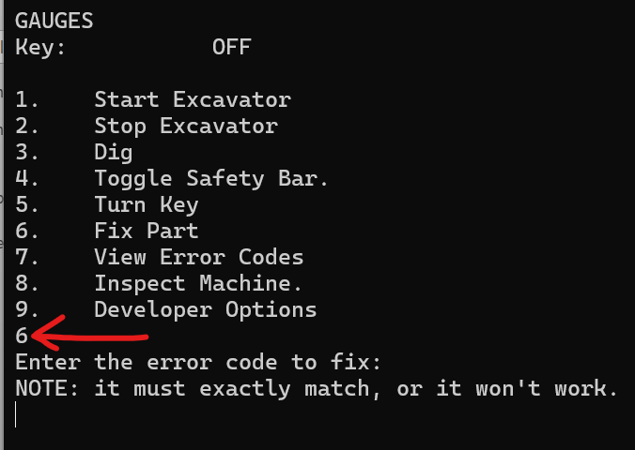

1. To fix the part, enter the error code as it appears in the troubleshooting manual. Please note that all error codes start with “zero x” (annunciated for understandability)
2. Below is an example of fixing a part by entering its code:

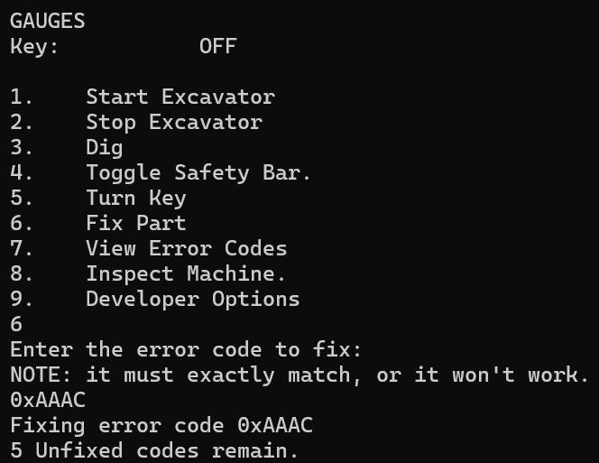

1. The number of unfixed codes will appear at the bottom of the screen.

## Refueling

Refueling is similar to a part breaking. You ‘fix’ this problem by going to option 6 – ‘fix part’.

You’ll know when you’re out of fuel, because when you try to crank the machine it will give this message:

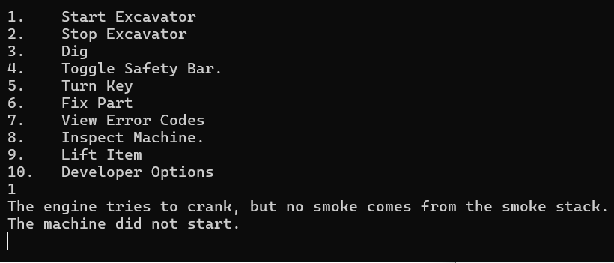

To fix this, you simply need to enter the correct fuel code: 0xAAAA

All you must do is choose option 6 from the menu by entering the number 6 with your keyboard. Then enter the code. This will purchase fuel and fill your tank. Press enter to continue.

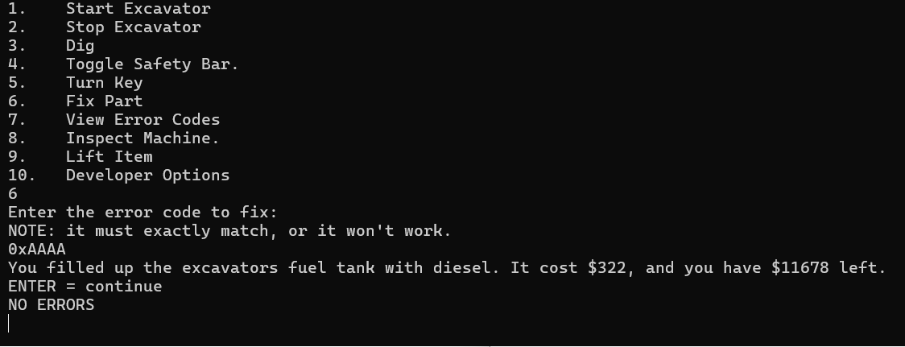

## Lifting

Lifting heavy objects with your excavator is the best way to make money. You gain more money the heavier the object is. Remember, it can only lift 205,000 lbs, any more and it will tip over and break things such as the engine, which are expensive to replace.

To lift an item, select option 9 from the menu:

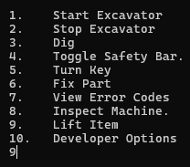

Press enter, and you will be shown a menu like this:

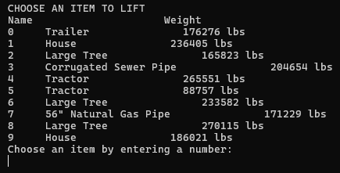

You can enter the number of the item you want to lift. Notice how the ‘large tree’ (item #6) is rated as 233,582 lbs. This is well over the maximum lift capacity of the excavator, so we will not choose it.

Instead, choose something under 205,000 lbs.

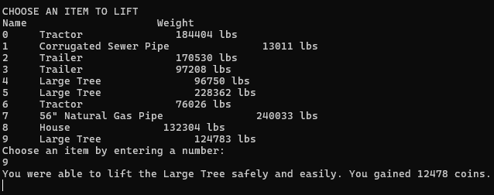

You can see on the bottom of the screen that there were 12478 coins gained.

## Digging

The excavator is designed to dig. It’s the most basic option, and is done by starting the excavator, enabling hydraulics, and then selecting option 3 – dig.

Toggle the key on by entering the number 5 and pressing enter.

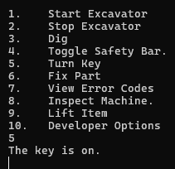

Next, press the number 4 with your keyboard to select option 4 from the menu. This lowers the safety bar so that you can use the excavator.

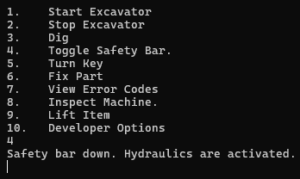

Next, use option 1 to start the engine.

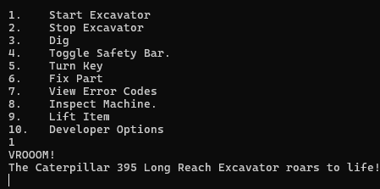

Next, enter the number 3 and press enter. This selects the option to dig.

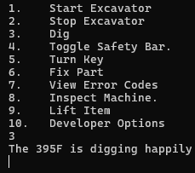

## Proper shutdown sequence

To shut down the excavator properly, you need to cool it down. The best option is to choose option 2 from the main menu. To do this, you simply enter the number two using the keyboard. Press enter. The excavator will warn to not shut down. If you press ‘y’ and enter, then the machine will be damaged. If you press ‘n’ and then enter, then the machine will not be damaged.

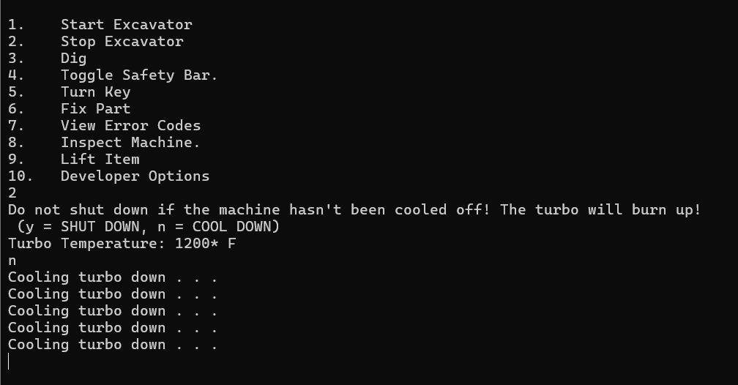

# Maintenance

## What are Error Codes for?

Error codes are for fixing the problem. The excavator can have symptoms, but it cannot tell you what is wrong. You must look up the symptom in the table, which will give you the correct error code. You type that error code into the machine and that fixes the problem. You must type the error code exactly as it appears. For example, the first characters will always be a zero and an x. The X must be lowercase. Then you type the remaining characters.

# Troubleshooting the Excavator

## The excavator does not start

You will need to know the critical path in order to inspect parts that are related to starting the excavator. Below is a description of things that must be functioning to start the excavator:

### Key

The Key must be on. You can turn on the key by selecting option 5 from the main menu. When you do this, the gauges should all show up.

### Engine

The engine must not be broken. While the engine can wear out, it can only really be in one of two states: broken or not broken. You can inspect the engine if you think it’s broken, please see “Checking if a part is broken”. The engine is critical for delivering power and energy to allow the excavator to move, charge its battery, everything. The machine can do nothing without the engine being functional. When the engine fails, it will make terrible screeching sounds during operation, and the machine will suddenly stop moving. You will smell burning oil. When this happens, your engine oil quality will be fully used up, and you must replace your engine oil to avoid severely damaging your new engine. If the engine is broken, you can input error code 0xAABC

### Engine Oil

Associated with the engine, the engine oil must be full. Without engine oil, the engine overheats and will break. If you experience a constantly breaking engine, your engine oil may have reached end of life (and will be dirty when you inspect it) or the engine oil has leaked out. If you suspect the engine oil is completely leaked out, then try error code 0xAACD If you suspect the engine oil needs replaced, try error code 0xAACE

### The turbo

Associated with the engine, **the turbo** must be operational. The turbo allows the engine to operate so powerfully, and in this kind of simulation, the excavator cannot operate without it. Inspect it using option 8 from the main menu if you believe it is broken. Usually, when the turbo is broken, there are metal scraping sounds when you try to start the engine. If you suspect the turbo is broken, try error code 0xAABC

### Fuel

Associated with the engine, the engine must have fuel to operate. It takes diesel fuel only. When you’re out of fuel, the engine will try to crank, but no smoke will come from the smokestack. The machine will not start. If you suspect the machine is out of fuel, then you can try entering 0xAAAA

Note: The fuel has its own critical path that must be clear of obstruction. Even if your excavator has fuel, if this path is blocked, then the excavator will not crank. The excavator has a fuel pump, fuel filter, and fuel lines. The fuel pump can wear out or break without warning. The fuel lines and fuel filter get clogged over time and must be replaced. Inspection of these elements is the best way to determine if they are broken.

### Fuel pump

The fuel pump can have 3 states, each representing how much fuel it can pump: 1, 2, or 3, which relates to how much fuel it can pump. This directly changes the RPM of the engine. The engine typically has about 500 RPM. If the RPM is about 400 and the machine takes a moment to start, making “chugugugugua, VROOM!” sounds, then this indicates a wearing pump in stage 2. If the excavator takes even longer to start, making sounds like this, “Chug, chug, chuuugugugugugugggaaVROOM!”, then the pump is almost at the end of its life, and is in stage 1, the lowest flow stage possible. The RPM will be about 300 engine RPM in this stage. If you suspect the fuel pump is broken or failing, then you can fix this by entering this error code: 0xAAAB

### Fuel lines

The fuel lines represent another part of the critical path of the fuel. If they are clogged, the machine will not crank. It will make sounds like this: “RRRRRRRRRRRRRRRRMMMMMMMMMMMMMVVVVVVVVVVVVVVVVVEEERRRRRRRRRRRRRRRRR!”, and it will not crank, no matter how long you hold the key. If you suspect the fuel lines are clogged, try entering code 0xAAAD

### Fuel Filter

The fuel filter is required to safely inject fuel into the engine. Without it, the engine might get particles into its injectors, which are very hard to replace. It’s much easier to replace a fuel filter. The amount that the filter is clogged will directly affect the RPM of the engine, and a mostly clogged filter will cause an RPM of about 400. If you suspect that the fuel filter is clogged, then you can enter the following code: 0xAAAE

### Battery

The battery must be charged. Without a battery, the machine cannot operate. If you suspect a failed or dead battery, you can inspect it by using option 8 in the menu. Please see, “Checking if a part is broken.” When the battery is not charging, it means that either the battery is end of life (too old to charge anymore) or the alternator isn’t working, (alternator is broken or the alternator belt is too lose to turn the alternator, which causes the battery to not charge) Either way, the battery will quickly drain or just stop charging, even with the machine is on. You will need a new battery. If you suspect that the battery is end of life, then you can enter the following code: 0xAADC The same code will work if the battery is dead.

## Other Parts that are Also Critical

These parts, if broken, will allow the excavator to start. However, performance will be impacted. It is possible to destroy the excavator if you continue operation under these conditions.

### Alternator Belt

The alternator belt is what transfers energy from the engine to the alternator. This is what allows the battery to be charged, and energy supplied to the excavator’s internal computer. Without this, the battery will eventually die. The belt gradually gets looser and looser as you operate the excavator. Eventually, the belt will completely fall off, and you’ll hear it flopping around in the back of the excavator. If you suspect the alternator belt is too lose, you may enter this code to fix it: 0xAADE

### Alternator

The alternator can fail without warning. The alternator is what charges the battery, enabling the engine to run. Without it, you will notice the battery draining quickly. If you suspect the alternator is broken, you can try entering the following code to fix it: 0xAADD

### Fuel Pump Belt

The fuel pump belt enables the fuel pump to work, delivering fuel to the engine to keep it running. Without the fuel pump belt, the belt will flop around in the back of the excavator. The excavator will slowly crawl to a stop. This is because the engine was slowly starving of fuel as it used up what was left in the fuel lines, then it shut off when the fuel was all gone. Be advised that the turbo will also be destroyed if the fuel pump belt loses its tension, as the excavator shuts down too abruptly for adequate cooldown. If you suspect the fuel pump belt is too lose to operate, then you can try entering the following code to fix it: 0xAAAC

### DEF Tank

DEF is used to allow the excavator to have cleaner emissions and is required for proper government compliance. The excavator has built in software to force the engine to move at a crawling 100 RPM if the DEF tank goes empty, making working impossible. This is a compliance feature designed to ensure that operators always use DEF. If you suspect the DEF tank is empty, then you can try entering the following code to fill it back up: 0xAAAF

### Engine Air Filter

The engine air filter is designed to protect the engine from sucking in small particles that would damage the engine’s internals. It is much cheaper to get a new filter than to get a new engine. Over time, the engine air filter will get clogged. Since a clogged engine air filter means an incorrectly shut down machine, the turbo will be destroyed and the engine will not start. If you suspect the engine air filter is obstructed and needs clearing, then you can try entering the following code to fix it: 0xAABA

### Radiator Fan Belt

The radiator fan belt is a belt which goes from the engine to the radiator. It transfers spinning energy from the engine to the radiator fan. This fan blows air over the radiator, cooling the coolant inside. That coolant is responsible for cooling the engine oil, and without it, the engine will surely overheat. Without the radiator fan belt, the machine cannot dig, but it can lift. If you suspect the radiator fan belt is too lose to operate, then you can try entering the following code to fix it: 0xAABD

### Radiator Filter

The radiator filter keeps the radiator fins from getting dirty. It does this by blocking particles from reaching the radiator fins. It’s important to note that when this gets blocked, the engine oil will heat up pretty fast, and your engine will be destroyed if it goes over 1000 degrees. If you suspect the radiator filter is too dirty to work, then you can try entering the following code to fix it: 0xAABE

### Radiator Fins

The radiator fins are what directly get air blown over them and cool the engine coolant. This is critical to keep the engine from overheating. If it gets obstructed, then the engine will quickly overheat. If you suspect the radiator fins are too dirty to use, then you can try entering the following code to fix it: 0xAABF

### Radiator Coolant

Radiator coolant is needed to cool the engine oil. Without radiator coolant, the engine oil will get drastically hotter until the engine overheats. There will a funny smell coming from behind the excavator and green fluid on the ground if the radiator is leaking. If you suspect the radiator is out of coolant, then you can try entering the following code to fix it: 0xAACC

### Radiator Pump

The radiator pump circulates radiator fluid through the radiator. This is so that each gallon of radiator fluid gets its own turn to be cooled by the fan blowing air across it. If the pump fails, then the engine oil will start to drastically heat up until the engine is destroyed. If you suspect the radiator pump is broken, then you can try entering the following code to fix it: 0xAACB

### Engine Oil Filter

The engine oil needs to be filtered so that only clean oil lubricates the engine. If the oil going into the engine is dirty, then the engine will be destroyed. It is much cheaper to install a new filter. If the engine oil filter gets obstructed, there is nothing lubricating the engine, and it will overheat instantly, being completely destroyed in the process. If you suspect the engine oil filter is clogged, then you can enter the following code to fix it: 0xAACF

## The excavator will not dig / lift

You will need to know the critical path in order to inspect parts that are related to digging and lifting.

**To dig, the excavator must be able to start and run**. If it does not run, it can neither dig nor lift items. You must go back to the section “The excavator does not start”

### Safety Bar

This safety bar is designed to save lives by prohibiting the operator from unintentionally moving the excavator. The user must toggle the safety bar to enable the machine to move. This is not a piece that breaks in the simulation.

### Hydraulic Oil

Without hydraulic oil, the pump will immediately break. You will hear a sound like this, “GHRKCRUNCHHHHGRIINNDDDDCRUNCHHHHH!” when trying to dig or lift. If you suspect that the machine is out of hydraulic oil, then you can try entering the following code to fix it: 0xAADF

### Hydraulic Oil Pump

The hydraulic oil pump is crucial for moving the excavator, and without it the excavator is unable to use its muscles – the hydraulic pistons. It is important to note that this is a part that can fail unexpectedly, but also wears out as you use it. If the excavator makes sounds like this as you move the joysticks to dig, you definitely have a broken hydraulic oil pump: “GHRKCRUNCHHHHGRIINNDDDDCRUNCHHHHH!” If you suspect the hydraulic oil pump is broken, then you can try entering this code to fix it: 0xAAEA

# Glossary of Terms

**Engine** - the part of the excavator that give power to the rest of the machine. It’s like a heart, or a muscle, or a battery. Without it, the excavator has nothing to give energy to its parts to do work.

**Engine Oil** – used to cool the engine.

Hydraulic oil pump – the part of the machine that actually actuates the muscles of the machine. Think of it as a muscle. Without muscles, you cannot move.

**Hydraulic Oil** – The hydraulic oil pump is useless without oil The pump uses the oil to push pistons. If all the pump has is air to push, then it will burn up, and air is too squishy to work well. The hydraulic oil pump must have hydraulic oil to push, to make the excavator move.

**Hydraulics / Hydraulic Pistons** – Think of these as the biceps. These pistons are filled with oil from the hydraulic oil pump. This causes the muscles to work.

**Battery** – The battery is required to start the engine. The battery is a way to store energy. When you want to start the engine, the battery gives up some of that energy so that the engine can start.

Troubleshooting Guide

# Common Problems

The turbo is by far the most common part which breaks. You can fix it by entering error code 0xAABB.

# Support

Talk to support if you’re having any issues: 563 239 0329

## Preventative Maintenance Checklist

You are provided with a list of critical components to check. Over time, a part will wear out and must be replaced. Your goal is to replace the part before it fails. Keep in mind that certain parts, such as the radiator, fuel pump, hydraulic oil pump, radiator pump, and alternator – can all fail without warning.

|  |
| --- |
| **Inspect Frequently** |
| *Fuel Pump* |
| *Fuel Pump Belt* |
| *Fuel Line* |
| *Fuel Filter* |
| Engine |
| Engine Oil |
| Engine Oil Pump |
| Engine Air Filter |
| *Radiator Fan Belt* |
| *Radiator Filter* |
| *Radiator* |
| *Radiator Pump* |
| Battery |
| *Alternator* |
| *Alternator Belt* |
| Hydraulic Oil |
| Hydraulic Oil Pump |
|  |

# Situational Error Codes Table

## WHEN STARTING

|  |  |  |
| --- | --- | --- |
| Code | Symptom | Reason |
| None | Chug, chug, chuuugugugugugugggaa | Check fuel pump volume, likely only 1gpm |
| None | Chuguguguga, VROOOM! The Caterpillar 395 Long Reach Excavator roars to life | The fuel pump volume = 2 |
| 0xAADC | You turn the key, but all you hear is a quiet click sound. The machine does not turn on. The gauges are all at 0.") | The battery is dead. (battery charge < 1) |
| 0xAAAA | The engine tries to crank, but no smoke comes from the smoke stack. | There is no fuel. |
| 0xAAAB | Chug, chug, chug, the engine did not start. | The fuel pump isn’t working. |
| 0xAAAE | WHIRRRRRRRRRRRRRRVVVVVVVVVVVVV The engine did not start. | The fuel filter is clogged. |
| 0xAAAD | RRRRMMMMMMVVVVVVVVVVEEERRRRRRRRRRRRRRRRR The engine did not start, no matter how long you hold the key. | The fuel lines are clogged. |
| 0xAABC | SCREECH! You hear something like gears grinding on metal in the back of the engine compartment. | The engine is broken. |
| 0xAACD | A slight buzzing sound happens when you turn the key, but the engine doesn’t start. | The engine is out of oil. |

## WHEN DIGGING / LIFTING

|  |  |  |
| --- | --- | --- |
| Code | Symptom | Reason |
| 0xAAEA | GHRKCRUNCHHHHGRIINNDDDDCRUNCHHHHH! A terrible grinding noise happens behind you as you move the joysticks. | The hydraulic oil pump is broken. |
| 0xAAAF | The machine digs very slowly, and the controls are not that responsive. The engine RPM is only (number) | The DEF tank is empty. It will need refilled. |
| None | You move the controls, but the machine doesn’t move at all. | The safety bar needs to be toggled. |
| 0xAACA |  | The radiator has a leak. |

## WHEN STOPPING

|  |  |  |
| --- | --- | --- |
| Code | Symptom | Reason |
| 0xAABB | wirrrrrRRRRR….SCREECH! | The turbo has overheated. It is destroyed. |
| 0xAABC | SCREECHEERUURRRRAARRCHHHH The engine suddenly halts. | The engine oil have overheated, causing the engine to be destroyed. |

## WHEN INSPECTING

|  |  |  |
| --- | --- | --- |
| Code | Problem / Symptom |  |
| 0xAADD | Alternator has no voltage across its wires | You must fix the alternator. |

# Complete Error Codes List

Problem: *Fuel lines blocked*

*CODE: 0xAAAD*

Problem: Fuel pump belt broken

CODE: 0xAAAC

Problem: Engine air Filter clogged

CODE: 0xAABA

Problem: The engine block has a crack in its side. You can see internal parts that shouldn't be exposed. This doesn't look good. It is broken.

CODE: 0xAABC

Problem: There is hydraulic oil everywhere.

Reason: hydraulic oil pump is end of life

CODE: 0xAAEA

Problem: There is engine oil everywhere.

Reason: engine oil empty

response: new engine oil, fix error code

CODE: 0xAACD

Problem: The engine oil filter is completely clogged. It must be replaced.

Reason: engine oil filter is obstructed

CODE: 0xAACF

Problem: As You look inside the filter, you see it is full of particles

Reason: engine oil filter is nearly fully obstructed

CODE: 0xAACF

Problem: the oil is dark black and thick to the touch. There are shiny flakes of metal in it.

Reason: the engine oil is end of life.

CODE: 0xAACE

Problems: no oil in oil filter. There is a burning smell in the air.

Reason: engine oil is empty.

CODE: 0xAACD

CAUTIONS: It is likely that there are other problems. The engine is likely destroyed.

Problem: fuel filter completely full of gummy diesel fuel.

Reason: the fuel filter is completely obstructed.

CODE: 0xAAAE

Problem: There is no oil inside of hydraulic oil pump

Reason: The hydraulic oil is gone.

CODE: 0xAADF

Problem: The blades of the hydraulic oil pump are destroyed

Reason: the hydraulic oil pump is destroyed

CODE: 0xAAEA

Problem: The radiator fan belt is too lose or degraded to operate

CODE: 0xAABD

Problem: There is radiator fluid inside the machine

CODE: 0xAACA

Problem: The engine smells burnt. There is obvious damage on the engine block.

CODE: 0xAABC

Problem: The radiator fins are so blocked that you cannot see the metal, just caked dust and mud.

CODE: 0xAABF

Problem: The radiator filter is very dirty. No air can get through it.

CODE: 0xAABE

Problem: The radiator pump is bone dry.

CODE: 0xAACC

Problem: The radiator pump blades are broken.

CODE: 0xAACB

Problem: alternator has no voltage across its wires

CODE: 0xAADD